LAB 3
Inshika Thakur

1.) What does each of the following commands do? Print the output and attach it as part of your Lab3 document
(a) cd /
(b) cd ~
(c) cd
(d) cd ..
(e) cd .
(f) cd -

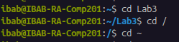
Ans 1)
a) cd / : This command takes us to the root directory.

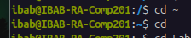
b) cd~ : This command takes us to the home directory.

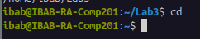
c) cd : This command takes us to the home directory.

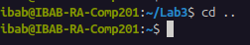
d) cd .. : This command takes us one directory behind.

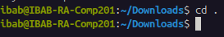
e) cd . : This command does not change our directory.

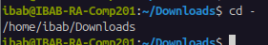
f) cd - : This command shows us the path of the current directory.

(2) When using the ls command, what is the difference between -R option and -r option? Demonstrate the difference by typing the appropriate commands and printing the output to your Lab3 document.
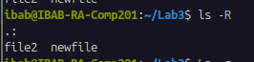
Ans 2)
ls -R : It shows the list of files in the current directory recursively

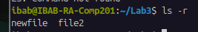
ls -r : This command lists the file in a reverse alphabetical order present in the directory.

(3) How do I find out what directory I am currently in?
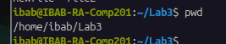
Ans 3) In order to know the current directory you are in you need to use the command : pwd

(4) How do I list files sorted by modification time, but with oldest first? Find the correct combination of options to do this task. Print the output of your command with appropriate screenshots to demonstrate this in your Lab3 document.
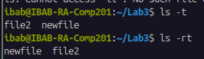
Ans 4) In order to list files sorted by modification time but in reverse we use the command :
ls -rt (r: reverse, t:sorts by time)

(5) What is the difference between (explain in your own words) ls -ltr and ls -l? Demonstrate the difference with appropriate screenshot and explanations.
Ans 5) So, ls -l is to list the files in a directory but in long format(in detail), which will also list the permissions, number of hard links, primary group etc. And on using the command ls -ltr it lists the files in the directory in detail but it sorts the list by modification time and in reverse.
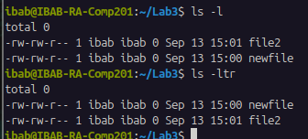

(6) What is the difference between ls -alF, ls -A and ls -CF. Demonstrate the difference with appropriate examples as screenshot and explanations.
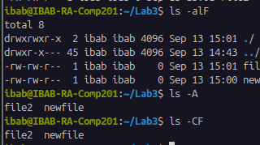
Ans 6) In ls -alF: It will list the hidden files, in long format and in the output it adds the character indicator at the end. (-a:it lists all the files along with the hidden file, -l:lists in long format, -F:character indicator)
In ls -A: It will list all the files including the hidden file but excludes the parent and current directory.
In ls -CF: It will list files column wise output and file indicator.

(7) Describe how you would use a combination of color codes in the command prompt appearance. Demonstrate this using an example where you managed to combine the colors blue and green?
Ans 7) In order to use a combination of color codes in the command prompt appearance, and combining the colors blue and green we will use the command:
PS1=’\[\e[0;34m\]\u@\h \[\e[0;32m\] :\w\$\[\e[0m\]

(8) Find the option of ls that lists the contents of a directory in the long format, but without the primary group information. (Note: ls -l lists files in the long format with the primary group information)
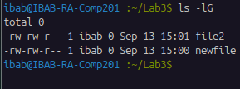
Ans 8)

(9) Download the etc.zip folder sent to you by email, unzip it and rename it as etc_learn. Change your directory to etc_learn. In this directory do the following using the necessary wildcards:
(a) list the files or directories starting with b
(b) list the files or directories starting with any of the letters from a-k
(c) list files or directories ending with d
(d) list the files or directories containing the pattern with conf. How many are there?
(e) Output the last three lines of the file /etc/resolve.conf
(f) list files that begin with g or l
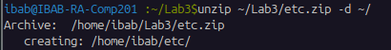
Ans 9)

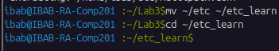

(a) In order to list the files or directories starting with b use the command:
ls *b
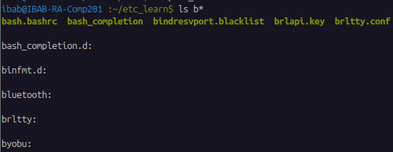
(b) command used to list the files or directories starting with any letter from a to k is:
ls [a-k]*
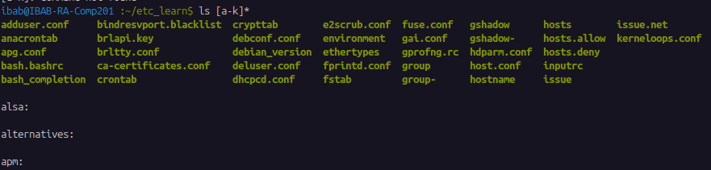
(c) To list the files ending with d we will use the command: ls *d
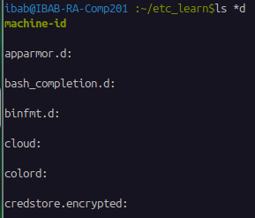

(d) To list the file or directory having the pattern conf we will use the command: ls *conf*
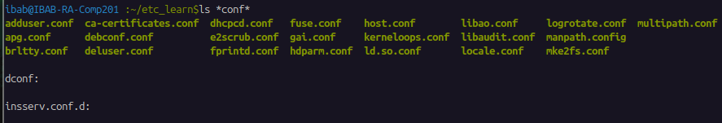
(e) Output the last three lines of the file /etc/resolve.conf we use the command:
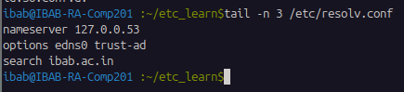
tail -n 3 /etc/resolv.conf

(f) In order to list the files that begin with g or l we will use the command:
ls g* l*
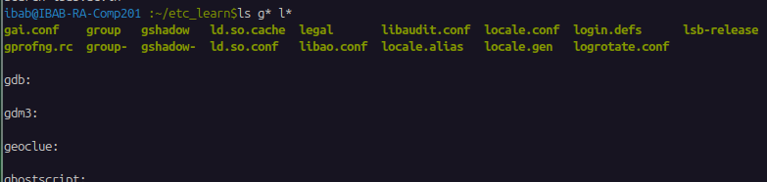
(10) Create the following directories: /home/ibab/lab3/Q10/q1 and /home/ibab/lab3/Q10/q2 using one command. Attach a screenshot of the commands and the outputs of this and below exercises in your document. (i) Enter the q1 directory using one command
(ii) Change directories from q1 to q2 using one command
(iii) copy the q1 directory to q1_copy
(iv) delete the q1_copy interactively
Ans 10) In order to create the two directories using one command we use the command:
mkdir -p /home/ibab/lab3/Q10/q1 /home/ibab/lab3/Q10/q2
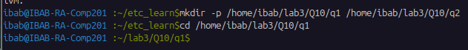
(a)
(b) to change directories using one command:
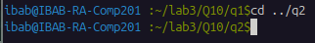

(c) To copy the q1 directory to q1_copy:
(d) delete the q1_copy interactively:
